ebm-papst Mulfingen GmbH&Co.KG
Postfach 1161
D-74671 Mulfingen
Internet: www.ebmpapst.com
E-Mail: info1@de.ebmpapst.com
Contact person for editors:
Katrin Lindner, E-Mail: Katrin.Lindner@de.ebmpapst.com
+49 7938 81-7006
Radial fan whistles snorer into sleep
Quiet breathing aid for medical use
Loss of breath during sleep, also known as sleep apnea, affects many people over 40 years of age. The number of people affected is in the double-digit percentage range, the ratio of men to women is about 5 to 1, daytime fatigue and attention deficit are the obvious effects of the disease. If untreated, it can also lead to hidden complications such as high blood pressure, cardiac insufficiency (diminished cardiac output), heart rhythm disturbances or myocardial infarction. A proven form of therapy supports the body's own respiratory reflexes through the controlled injection of air into the lungs. A new, highly dynamic centrifugal fan now supports breathing through the controlled supply of fresh air. The lightweight, efficient small fan is also well suited for long battery operation, for example for a mobile sleep therapy device. Other applications in medical technology include mechanical intensive care ventilation, mucus secretion mobilization and mobile air filter technology, e.g. respiratory protection devices.
The reliability of medical devices and their components is particularly important. Particularly when using apnea machines at home or as a ventilator in the intensive care unit, simple operation is also important. If, for example, a ventilator is used during sleep, such a device must be located close to the user and must not interfere with healthy sleep due to operating noises. In order to meet these requirements, the fan and drive specialist ebm-papst from St. Georgen in the Black Forest developed the RV45 radial fan for ventilators and similar dynamic applications that meets these requirements - safe, reliable, efficient and quiet (Fig. 1).
How does mechanical ventilation work?
The technology behind it is easy to understand: Air pressure generated by the fan inflates the lungs and thus supports breathing. But the trick is in the details: The application requires highly dynamic fan operation, meaning very rapid changes in speed. However, smooth running in dynamic operation is not easy to implement. The biological properties of breathing demand swift and smooth control of the air flow and pressure. For example, it is often necessary to generate a high "blowing pressure" for a short time at the beginning of the inhalation sequence. This pressure raises the flaccid soft palate and allows air to enter the windpipe. However, this "initial high air pressure" may only be applied very briefly and it must rise quickly, but not abruptly, in order to give the palate the necessary time to clear the windpipe. After opening the soft palate, the pressure must be quickly reduced to the inhalation level prescribed by the doctor and sustained at this level. To match the patient's respiration, the supporting flow rate and pressure must be constantly adjusted. In order to exhale, the pressure must then drop quickly again, but not abruptly, in order to allow unhindered exhalation. For the breathing dynamics, approximately 200 ms control time is typical with volume flows around 150 l/min and pressure fluctuations from 400 Pa to 2,000 Pa. The pressure should be kept as low as possible and never exceed 3,500 Pa to avoid lung damage. On the other hand, the adjustable high volume flow rate is important in order to be able to reliably compensate for leaks, e.g. in the respiratory mask due to poor fit or in the case of bearded wearers. In order to regulate the necessary variation in volume flow and pressure in practice, the speed of the radial fan must therefore be quickly increased or decreased. The compact fan RV45, which has been optimized in terms of aerodynamics and motor dynamics, provides the necessary air flow and drive technology. Despite the strongly fluctuating operating conditions, the RV45 meets the absolute quietness required so as not to disturb the sleep of the patient or anyone else sleeping nearby.
Technology in medical service
How can the different requirements be translated into a product that can be used as universally as possible? The basic prerequisite is the use of FDA-compliant materials for air-contacting parts that meet all relevant regulations worldwide. At the same time, the entire aerodynamics of the fan was adapted to the application. Both at high and low revs, the air flow noise was significantly reduced. The RV45 is designed for use in CPAP (Continuous Positive Airway Pressure) and for operation with automatic pressure adaption (APAP/auto APA and BiLevel/BIPAP). The motor, control electronics and the aerodynamics are designed in a way that each part supports the other in order to reach those diverse requirements by synergy.
In order to equip the centrifugal blower optimally for the widest possible range of applications, the Black Forest specialists chose a highly dynamic, EC (electronically commutated) internal rotor motor as the drive. The low moment of inertia of the rotor equipped with a powerful magnet accommodates the required dynamics. The magnet and coil design, was further optimized through extensive simulation and testing. At the same time, the detent torque and structure-borne noise excitation have been minimized and efficiency improved. Since only the bearings of the EC motor are subject to wear and tear, the use of maintenance-free ball bearings with special grease lubrication enabled the service life to be increased to 50,000 hours L_{10IPC} (25 °C) after the stricter, in-house ebm-papst test conditions were passed. This corresponds to about 6,250 nights or about 17 years with 8 hours of sleep per night.
Because the delivery rate (linear) and the delivery pressure (square) of a radial fan impeller increase with the speed, the high speed of up to 50,000 rpm allows the fan to be very compact. The motor drive and control electronics are not included inside the RV45 blower and must be provided externally, which offers advantages in matching the fan to the respective task. Depending on the medical device, the user can provide their own specifically optimized control system. However, for a wide range of standard tasks or fast test operation, a control module from the manufacturer is available which is specially adapted to the motor. This "Power Module RV45" is suitable for simple speed control and includes a tachometer output, thus offering a plug & play solution for the customer. This can be useful in both medical and industrial applications, e.g. for the dynamic ventilation of fuel cells, air filter technology, packaging machines, smoke detection systems, printed circuit board production or exhaust air systems for soldering and welding gases as well as breathing apparatus and similar devices. A version of the RV45 fan with Hall IC sensors in the motor, for a simpler in-house development of the control electronics including an NTC temperature sensor option, is available as a customer option.
Economical and compact
The RV45 is very compact with only 64 x 69.5 x 54.5 mm and is available for operation on two voltages 12 and 24 VDC. The power consumption is around 43 W in free blowing operation, but running in typical applications with speed control can often average 20 W lower, which also ensures long running times in battery operation. The possible high power consumption is indispensable for the short-term "sprint" in order to fulfill the requirements on high dynamic operation. The maximum free blowing air flow is up to 410 l/min and the maximum pressure increase is over 5,000 Pa (Fig. 2). This is sufficient for large lung volumes, heavy soft palate cases or for use in secretion mobilization. All air-contacting parts of the 135 g light-weight fan are constructed from FDA compliant materials which are harmless to human respiratory physiology. Thanks to the selected vibration damping materials and the optimized aerodynamic design, the operating noise is minimized and is at a level similar to a whispering conversation. Built into a suitable, sound-absorbing housing, any sleep disturbance will be minimal (Fig. 3).
Info box:
Sleep apnea: What is it?
About 10 % of all sleepers over 40 years of age are affected by sleep apnea worldwide, i.e. temporary respiratory arrests that occur during sleep. Sleep apnea syndrome is likely to occur if there are more than ten respiratory arrests per hour that last longer than 10 seconds. The periods of breathing cessation occur up to twenty times an hour in severe cases. The breathing pause is registered in the sleeper's brain and overcome by an awakening reaction. This wake-up reaction is vital and prevents suffocation but disturbs sleep. The sleeper changes from a deep sleep stage to a superficial sleep. Snorers in particular are affected by this disease. Due to sleep disturbances and lack of oxygen supply during the respiratory arrest phases, the patient feels unrested and tired in the morning, often with daytime sleepiness and a lack of attention. In addition, chronic untreated apnea syndrome can often lead to high blood pressure, heart failure (diminished cardiac output), cardiac arrhythmias and an increased tendency to heart attacks and strokes.

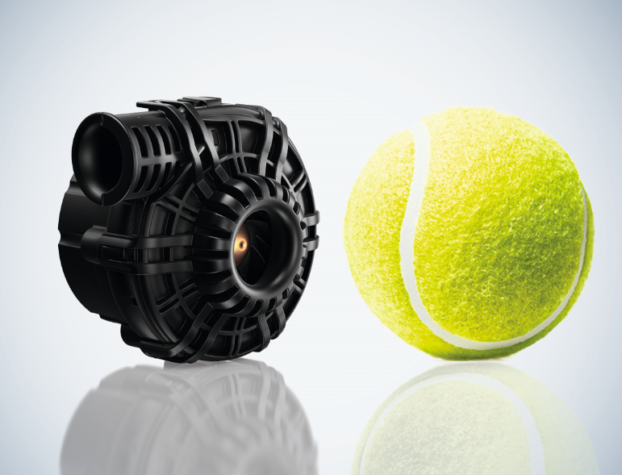
Fig 1: The RV 45 offers highly available, efficient and quiet air delivery.
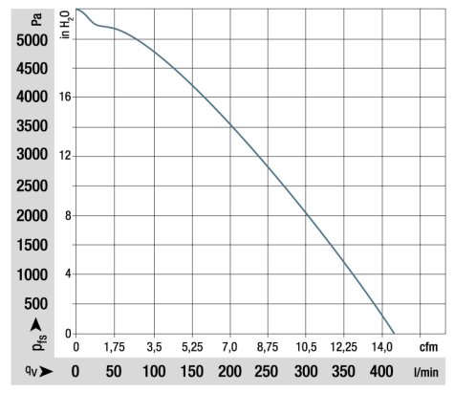
Fig 2: The maximum free blowing air flow is up to 410 l/min and the maximum pressure increase is over 5,000 Pa.
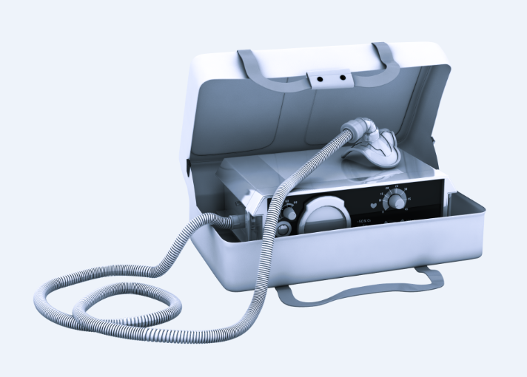
Fig 3: If the fan is installed in a suitable, noise-damping device housing, no disturbance is to be expected even at night.

Text Martin Sauter, Team Manager Sales - Industrial Air Technology, ebm-papst St. Georgen GmbH & Co. KG
Figures ebm-papst
Characters ca. 9,800, including headings and sub-headings, and box text
Keywords sleep apnea, respiratory, CPAP
Link www.ebmpapst.com/rv45

